Poimenuj sestavne dele dvotaktnega motorja. Nekateri deli so razvidni na spodnji sliki.

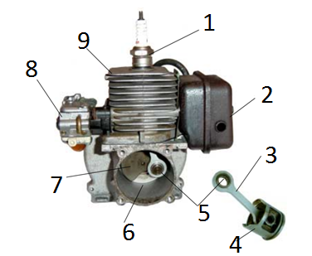
1 ________________________________________
2 ________________________________________
3 ________________________________________
4 ________________________________________
5 ________________________________________
6 ________________________________________
7_______________________________________
8 ______________________________________ 9 _______________________________________
10______________________________________ 11 ______________________________________
12______________________________________ 13______________________________________
Na kratko opiši dogajanje v prvem in drugem taktu pri dvotaktnem motorju.
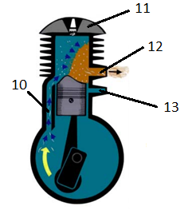
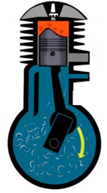

Prvi takt Drugi takt
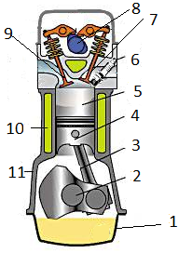
_____________________________________________________________________________________________________________________________________________________________________________________________________________________________________________________________________________________________________________________________________
Poimenuj sestavne dele štiritaktnega motorja.
1 ________________________________________
2 ________________________________________
3 ________________________________________
4 ________________________________________
5 ________________________________________
6 ________________________________________
7 ________________________________________
8 ________________________________________
9 ________________________________________
10 _______________________________________
11 _______________________________________
Na kratko opiši dogajanje pri posameznem taktu pri štiritaktnem motorju.
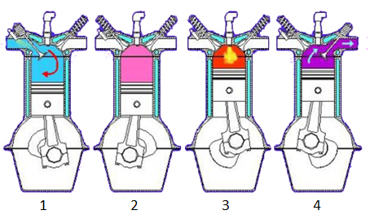
1. ______________________________________________________
2. ______________________________________________________
3. ______________________________________________________
4. ______________________________________________________

