9. razred, ANGLEŠČINA
Pouk na daljavo, 25. marec 2020, 5. ura
Distance learning during temporary school closure
ZAPOREDNA ŠT. URE pouka na daljavo: 5 | DATUM: 25. 3. 2020 | RAZRED: 9.
NASLOV URE: A Green Quiz
Passive voice
Hello, everyone. How green are you? Do the quiz and find out.
IMPORTANT!
Prosim, vpišite se v spletno učilnico za angleščino. Ključ: Future
IDIOM TO BE GREEN means:
- to be concerned for the environment;
- immature in age or judgment;
- untrained; inexperienced
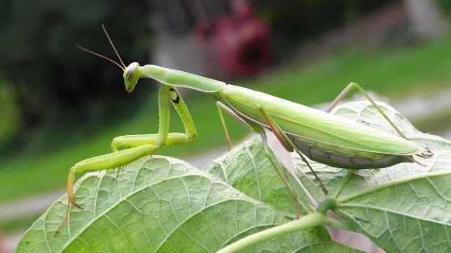

STUDENT’S BOOK, p. 61: Read the quiz A Green Quiz and answer the questions.

STUDENT’S BOOK, p. 61/7: How green are you? Write your answers.

WORKBOOK p. 47/5: Check the exercise!
2 were stolen 3 was seen 4 was stopped 5 were found 6 were taken
7 was arrested 8 was watched 9 were seen 10 was sent 12 will be created 13 will be used
14 will be flooded 15 will be covered 16 will be built

17 will be organized 18 will be stopped 19 will be saved 21 has been reoved 22 have beeen rescued 23 have been taken 24 have been cleaned 25 have been released 26 has been removed 27 have been killed

