5. razred, ANGLEŠČINA, OŠ Col
POUK NA DALJAVO, 2.april 2020, četrtek
Distance learning during temporary school closure

NASLOV URE: Wolf! (basen v stripu)
ZAPOREDNA ŠT. URE pouka na daljavo: 9. | DATUM: 2. 4. 2020 | RAZRED: 5.
Hello, everyone. Today you are going to read a story Wolf!
Učbenik, str. 64, 65
This is a story about a SHEPHERD. Do you know what does a shepherd do? He watches the sheep.
sheep - ovce herd- čreda
Characters: Sami – a shepherd, people, sheep, a wolf

WE ARE SHEPHERDS, TOO!
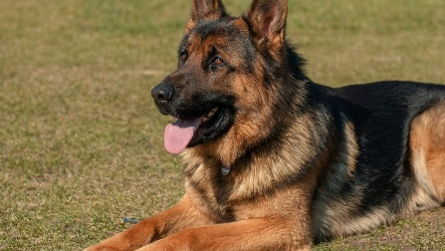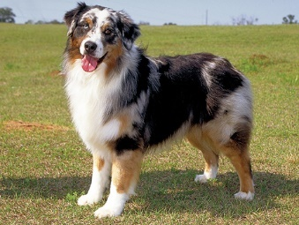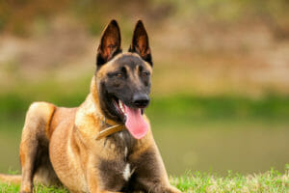
German shepherd Austalian shepherd Belgian shepherd
Foto: https://www.rover.com/blog/breed-article-german-shepherd/
https://www.zivalnik.si/novice/avstralski-ovcar-australian-shepherd/?piskotki_opcija%5B%5D=obv
https://scottsk9.com/cost-of-owning-a-trained-belgian-malinois/
Preberi besedilo WOLF! Učbenik, str. 64, 65

1. Why did the boy Sami say Wolf! for the first time? Was it true?
The boy was bored. (Dogočasil se je.)
Was it a lie or a joke? (Je bila to laž ali šala?)
People were very worried and confused. (Ljudje so bili zaskrbljeni in zmedeni.)
People were angry. (Ljudje so bili jezni.)

2. Why did Sami say ‘Wolf!’ for the second time? Was it true or a joke?
Who taught it was funny? Sami or people? (Kdo je mislil, da je smešno?)
The wolf chases the sheep and the sheep run away.
(Volk je pregnal ovce. Ovce so se razbežale.)
What did Sami learn from his experience? (Kaj se je Sami naučil iz te izkušnje?)

Liars are not believed even when they speak the truth.
(Lažnivcem ne moreš verjeti, tudi ko govorijo resnico.)

Ali: Kdor se enkrat zlaže, se mu nikoli več ne verjame.

Delovni zvezek, str. 54, vaja 2; str. 55, vaja 1
Delovni zvezek, str. 84 – uredite si slikovni slovar.

Poslušanje pravljice: Več različic Ezopove basni si lahko ogledate na spletu (You Tube). Naslov pravljice v angleščini: The Boy who cried Wolf! https://www.youtube.com/watch?v=gKWktweAZb0

