Pouk na daljavo – 16. 3. 2020

Dragi učenci, drage učenke!
Tudi pouk angleščine bo do nadaljnjega potekal na daljavo. Navodila za delo boste prejeli trikrat tedensko, predvidoma ob ponedeljkih, sredah in četrtkih.

Danes najprej ponovite glagole, ki jih uporabljamo pri kuhanju (bake, boil, chop, cut, grate, grill, mash, peel, slice, spread, sprinkle, squeeze, stir, whisk, pour, put, add, mix, cook, drain …). S pomočjo spletnega slovarja (https://sl.pons.com/prevod) preverite, če res veste, kaj glagoli pomenijo. Glagole in prevod si zapišite v zvezek.
Nato poglejte učni list spodaj, preberite navodila in si oglejte sličice. Upoštevajte navodila in v zvezek napišite recept za špagete z zelenjavo.

Kdor potrebuje pomoč pri reševanju nalog, mi lahko svoja vprašanja pošlje po elektronski pošti na naslov kristina.tratnik@os-col.si.

Write the instructions to make this recipe: Spaghetti with vegetables
- Write the title: How to make……………….
- Who is this recipe from? (You can invent)
- Describe this meal, use different adjectives. (easy, delicious, tasty….)
- Say your opinion about it.
- Look at the images and write a list of the ingredients. You can invent the quantities. Remember to use SOME for the uncountable nouns.
- Write the instructions according to the order of the pictures. Use connectors: first, then, after that, next, finally.
Use these expressions
“When it is cooked....” /“When they are soft…”/“Be careful”/
“You mustn’t…” /“Cook for…minutes”
Use the verbs: cook, add, chop, drain, mix, put
- Finish giving an idea of another ingredient. Use the verb CAN.
You can also eat this with……….
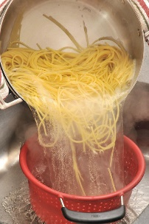
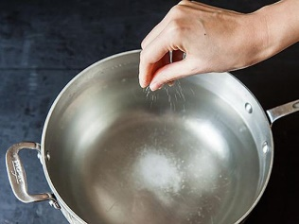

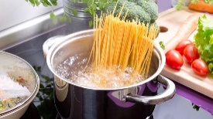

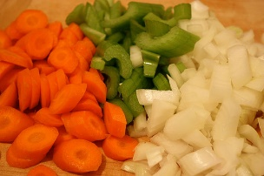

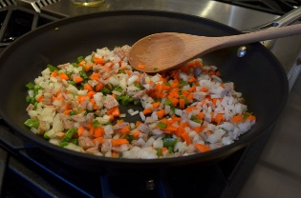
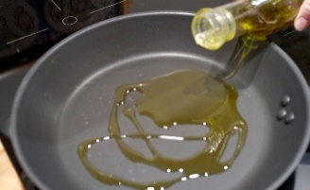

Yum!!
Enjoy!!

